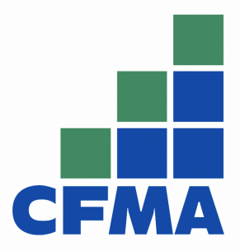
The Colorado Chapter of the Construction Financial Management Association is now accepting applications for college scholarships.
ELIGIBILITY
To be eligible, the applicant must be a Construction Financial Management Association Colorado Chapter member, family member of a member or employee of a company that has a member.
The applicant must be attending or have plans to attend an accredited college or university.
The scholarships may be awarded on the basis of: (a) membership status and participation in the Colorado Chapter; (b) educational needs (c) an interest in accounting and/or construction and d) the number of applicants.
APPLICATION
Applications are due by June 24th, and will be reviewed for approval by July 15th, by the Scholarship committee of the CFMA Colorado chapter, with final approval by the board of directors. The scholarship winners will be notified as soon as possible after the decisions have been finalized.
To be considered for an award, application packets should include all of the following items:
- Completed Scholarship Application (attached)
- An original 250- 500 word essay explaining why the applicant is seeking the scholarship.
- The Applicants relationship to the Colorado Chapter of CFMA
- Two references

QUESTIONS AND SUBMISSIONS TO:

Sylvia Sevier, Scholarship Committee Chair
Haselden Construction LLC 303-751-1478 or sylviasevier@haselden.com

2022 CFMA-Colorado chapter

scholarship application

(Please Print or Type)

NAME: _______________________________________ phone: ______________________

address: __________________________________________________________________
City: _________________________________ STATE: _____________ ZIP: __________

eMAIL ADDRESS: ___________________________________________________________

Persons relationship to Cfma:

_____ Member _____ Dependent of Member

______ Employee of Member Company

________________________________ Name of Member

________________________________member’s company
Name of school: __________________________________________________________
Overall Gpa: ______________ graduation date: ___________________
Major/Minor: ____________________ Expected degree: ___________________
Current status: _____ freshman ______ SOPHOMORE ______ JUNIOR _____ Senior _____ Graduate program
_____ other (sPECIFY)______________________________________________________

Total HOurs currently enrolled: __________________

list two references (other than relatives) including their name, address, phone number, and the profession of each:
- ________________________________________________________________________
________________________________________________________________________
________________________________________________________________________
- ________________________________________________________________________
________________________________________________________________________
________________________________________________________________________

the information i have submitted is complete and accurate to the best of my knowledge. any false information may result in retraction of any scholarship awarded.
your signature authorizes release of student’s name, photograph, and school to the media and for CFMA publications and website.

signature: ________________________________________ date: _________________

Additional requirement:

create a pdf document with the completed application and AN ORIGINAL 250 TO 500 WORD ESSAY EXPLAINING WHY THE APPLICANT IS SEEKING A SCHOLARSHIP AWARD.

SUBMIT TO sylviasevier@haselden.com

